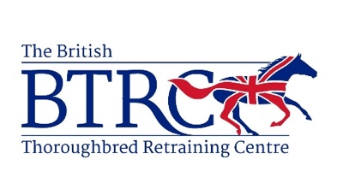

Application for BTRC Stable Staff (2024)
(All applicants must be 16 years+)
Name
Current Occupation
Contact Number
Date of Birth
Email Address
Home Address
Do you have a current driving license?
Previous equestrian experience - please include any qualifications or other relevant information.

Why do you want to work for a charity such as BTRC?
Please note any current commitments/notice period etc.
Please provide details of two references (one must be equine based)
Criminal convictions -
Please give details of any criminal convictions.

Thank you very much for your application.
Please return this form by 3rd May 2024 via email to enquiries@thetrc.co.uk

